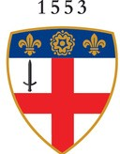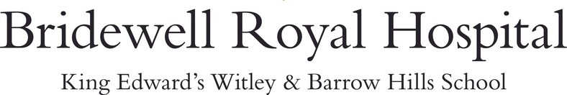

Personal Details
Gift Form

NAME ADDRESS
POST CODE
TEL | EMAIL

Gift Aid Declaration
Boost your donation by 25p of Gift Aid for every £1 you donate.
Gift Aid is reclaimed by us as a registered charity from the tax you pay for the current tax year. Your address is needed to identify you as a current UK taxpayer. In order to Gift Aid your donation you must tick the box below:
I want to Gift Aid my donation and any donations I make in the future, or have made in the past four years, to Bridewell Royal Hospital T/A King Edward's School, Witley.
I am a UK taxpayer and understand that if I pay less Income Tax and/or Capital Gains Tax in the current tax year than the amount of Gift Aid claimed on all my donations it is my responsibility to pay any difference.
SIGNATURE
DATE

I would like to make a single gift of
£20

£50
£100
or £

I have enclosed a cheque or CAF voucher made payable to Bridewell Royal Hospital T/A King Edward's School, Witley.
I have made a bank transfer to Bridewell Royal Hospital T/A King Edward's School, Witley.
Barclays Bank, sort code: 20-17-27, account number: 23025519. Please use your surname as the reference.

I wish to make a recurring gift to Bridewell Royal Hospital T/A King Edward's School, Witley of

£20

£50

£100

or £

Each
Month
Quarter
Year
M M
By Direct Debit - please complete the instruction overleaf
Y Y

Starting

1st

15th of
/ for

years, or until further notice

Other Information
I wish my gift to remain anonymous

I am considering a gift in my Will and would like further information on legacies I have already made provision for a gift in my Will
If you have any queries please email development@kesw.org or call 01428 686 773
Bridewell Royal Hospital, incorporating King Edward's Witley, is a registered charity no. 311997

Data Protection: Your data is held in the strictest confidence and may be used by Bridewell Royal Hospital T/A King Edward's School, Witley, it's agents and recognised alumni clubs for a range of activities including sending publications offering benefits and services, organising reunions and in our fundraising activities. If you prefer not to be included in these activities, please contact us on development@kesw.org and we will update our records.

Please fill in the whole form using a ball point pen and send it to:
Instruction to your Bank or Building Society to pay by Direct Debit

Service user number
4 5 5 3 3 8
External Relations
King Edward's Witley Petworth Road Godalming
Surrey GU8 5SG

Name(s) of Account Holder(s)

Bank/Building Society account number

Branch sort code

Reference - for office use only

Instruction to your Bank or Building Society
Please pay Bridewell Royal Hospital T/A King Edward's School, Witley Direct Debits from the account detailed in this instruction subject to the safeguards assured by the Direct Debit Guarantee. I understand that this instruction may remain with Bridewell Royal Hospital T/A King Edward's School, Witley and, if so, details will be passed electronically to my bank/building Society.

Name and full postal address of your Bank or Building Society
To: The Manager
Bank/Building Society

Address
Post Code
Signature(s)
Date

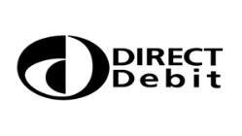
Banks and Building Societies may not accept Direct Debit Instructions for some types of account
This guarantee should be detached and retained by the payer.

The Direct Debit Guarantee
This Guarantee is offered by all banks and building societies that accept instructions to pay Direct Debits. If there are any changes to the amount, date or frequency of your Direct Debit, Bridewell Royal Hospital T/A King Edward's School, Witley will notify you 10 working days in advance of your account being debited or as otherwise agreed.
If you request Bridewell Royal Hospital T/A King Edward's School, Witley to collect a payment, confirmation of the amount and date will be given to you at the time of request.
If an error is made in the payment of your Direct Debit, by Bridewell Royal Hospital T/A King Edward's School, Witley or your bank or building society, you are entitled to a full and immediate refund of the amount paid from your bank or building society - if you receive a refund you are not entitled to, you must pay it back when Bridewell Royal Hospital T/A King Edward's School, Witley asks you to.
You can cancel a Direct Debit at any time by simply contacting your bank or building society. Written confirmation may be required. Please also notify us.

